**Course**: Programming Fundamental – ENSF 337  
**Lab #**: Lab 4  
**Instructor:** M. Moussavi  
**Student Name:** Carl Soriano  
**Lab Section:** B01  
**Date submitted:** Oct 5, 2022

Exercise A

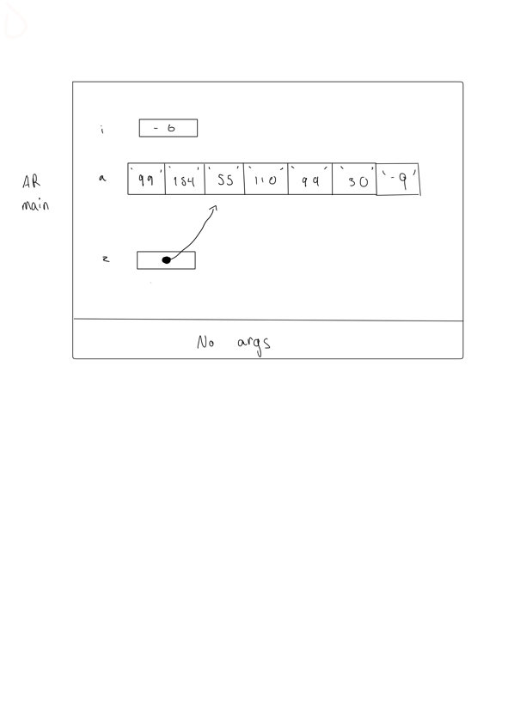

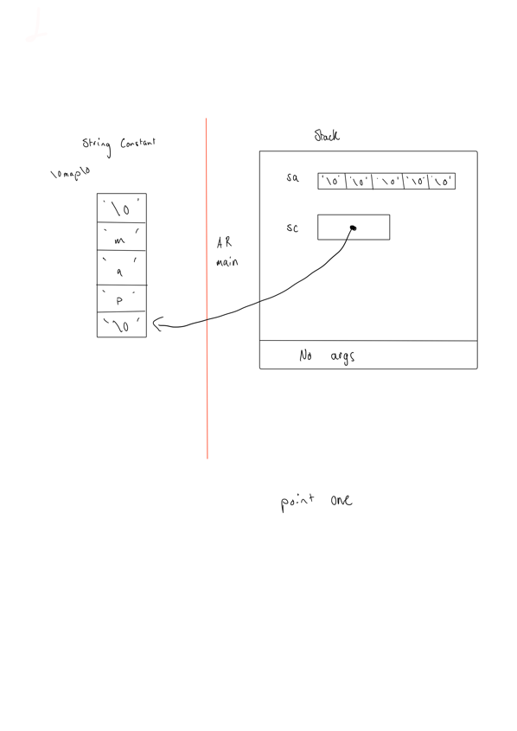Exercise B

Exercise C

// lab2exC.c

// ENSF 337 Lab 4 Exercise C

//

#include <stdio.h>

#define ELEMENTS(x) (sizeof(x)/sizeof(x[0]))

//indexs x[0] it gives the size of the specific element IE int or double

**int** main()

{

**int** size;

**int** a[] = {45, 67, 89, 24, 54};

**double** b[20] = {14.5, 61.7, 18.9, 2.4, 0.54};

size = ELEMENTS(a);

printf("Array a has 5 elements and macro ELEMENTS returns %d\n", size);

size = ELEMENTS(b);

printf("Array b has 20 elements and macro ELEMENTS returns %d\n", size);

**return** 0;

}

Exercise D

strncat(my_string, str3, 6);

printf("\nExpected to display: my_string contains \"tic-tac-toe\"");

printf("\nmy_string contains:\"%s\"", my_string);

length = (**int**) strlen(my_string);

printf("\nExpected to display: my_string has 11 characters.");

printf("\nmy_string has %d characters.", length);

printf("\n\nUsing strcmp - C library function: ");

printf("\nExpected to display: \"ABCD\" is less than \"ABCDE\"");

printf("\n\"ABCD\" is less than \"ABCDE\"... strcmp returns %d", strcmp("ABCD", "ABCDE"));

printf("\n\nTESTING strcmp FUNCTION ... \n");

**if**((y = strcmp("ABCD", "ABND")) < 0)

printf("\n\"ABCD\" is less than \"ABND\" ... strcmp returns %d", y);

**if**((y = strcmp("ABCD", "ABCD")) == 0)

printf("\n\"ABCD\" is equal \"ABCD\" ... strcmp returns %d", y);

**if**((y = strcmp("ABCD", "ABCd")) < 0)

printf("\n\"ABCD\" is less than \"ABCd\" ... strcmp returns %d", y);

**if**((y = strcmp("Orange", "Apple")) > 0)

printf("\n\"Orange\" is greater than \"Apple\" ... strcmp returns %d\n", y);

**return** 0;

}

**int** my_strlen(**const** **char** *s)

{

**const** **char** *length = s;

**while** (*length != '\0')

length++;

**return** (**int**)(length - s);

}

**void** my_strncat(**char** *dest, **const** **char** *source, **int** n)

{

**char** *temp = dest;

**while**(*dest){

dest++;

}

**while**(n && *source){

n--;

*dest = *source;

dest++;

source++;

}

*dest = '\0';

dest = temp;

}

**int** my_strncmp(**const** **char**\* str1, **const** **char**\* str2)

{

**for**(**int** i = 0; ;i++)

{

**if**(*str1 == '\0' && *str2 == '\0')

{

**return** 0;

}

**int** ascii1 = (**int**)*str1;

**int** ascii2 = (**int**)*str2;

**if**(ascii1>ascii2)

**return** 1;

**if**(ascii2>ascii1)

**return** -1;

}

}

/*

* lab4exD.c

*

* ENSF 337 Lab 4 Exercise D

*

*/

#include <stdio.h>

#include <string.h>

**int** my_strlen(**const** **char** *s);

/* Duplicates strlen from <string.h>, except return type is int.

* REQUIRES

* s points to the beginning of a string.

* PROMISES

* Returns the number of chars in the string, not including the

* terminating null.

*/

**void** my_strncat(**char** *dest, **const** **char** *source, **int** n);

/* Duplicates strncat from <string.h>, except return type is void.

* dest and source point to the beginning of two strings.

* PROMISES

* appends source to the end of dest. If length of source is more than n.

* Only copies the first n elements of source.

*/

**int** my_strncmp(**const** **char**\* str1, **const** **char**\* str2);

/* Duplicates strcmp from <string.h>, except return type is int.

* REQUIRES

* str1 points to the beginning of a string, and str2 to the beginning of

* another string.

* PROMISES

* Returns 0 if str1 and str2 are idntical.

* Returns a negative number of str1 is less that str2.

* Return a psitive nubmer of str2 is less than str1.

*/

**int** main(**void**)

{

**char** str1[7] = "banana";

**const** **char** str2[] = "-tacit";

**const** **char**\* str3 = "-toe";

**char** str5[] = "ticket";

**char** my_string[100]="";

**int** bytes;

**int** length;

**int** y;

printf("\nTESTING strlen FUNCTION ... \n");

/* using strlen function */

length = (**int**) my_strlen(my_string);

printf("\nExpected to display: my_string length is 0.");

printf("\nmy_string length is %d.", length);

/* using sizeof operator */

bytes = **sizeof** (my_string);

printf("\nExpected to display: my_string size is 100 bytes.");

printf("\nmy_string size is %d bytes.", bytes);

/* using strcpy C libarary function */

strcpy(my_string, str1);

printf("\nExpected to display: my_string contains banana.");

printf("\nmy_string contains %s", my_string);

length = (**int**) my_strlen(my_string);

printf("\nExpected to display: my_string length is 6.");

printf("\nmy_string length is %d.", length);

my_string[0] = '\0';

printf("\nExpected to display: my_string contains \"\".");

printf("\nmy_string contains:\"%s\"", my_string);

length = (**int**) my_strlen(my_string);

printf("\nExpected to display: my_string length is 0.");

printf("\nmy_string length is %d.", length);

bytes = **sizeof** (my_string);

printf("\nExpected to display: my_string size is still 100 bytes.");

printf("\nmy_string size is still %d bytes.", bytes);

printf("\n\nTESTING strncat FUNCTION ... \n");

/* strncat append the first 3 characters of str5 to the end of my_string */

strncat(my_string, str5, 3);

printf("\nExpected to display: my_string contains \"tic\"");

printf("\nmy_string contains \"%s\"", my_string);

length = (**int**) strlen(my_string);

printf("\nExpected to display: my_string length is 3.");

printf("\nmy_string length is %d.", length);

strncat(my_string, str2, 4);

printf("\nExpected to display: my_string contains \"tic-tac\"");

printf("\nmy_string contains:\"%s\"", my_string);

/* strncat append ONLY up ot '\0' character from str3 -- not 6 characters */

strncat(my_string, str3, 6);

printf("\nExpected to display: my_string contains \"tic-tac-toe\"");

printf("\nmy_string contains:\"%s\"", my_string);

length = (**int**) strlen(my_string);

printf("\nExpected to display: my_string has 11 characters.");

printf("\nmy_string has %d characters.", length);

printf("\n\nUsing strcmp - C library function: ");

printf("\nExpected to display: \"ABCD\" is less than \"ABCDE\"");

printf("\n\"ABCD\" is less than \"ABCDE\"... strcmp returns %d", strcmp("ABCD", "ABCDE"));

printf("\n\nTESTING strcmp FUNCTION ... \n");

**if**((y = strcmp("ABCD", "ABND")) < 0)

printf("\n\"ABCD\" is less than \"ABND\" ... strcmp returns %d", y);

**if**((y = strcmp("ABCD", "ABCD")) == 0)

printf("\n\"ABCD\" is equal \"ABCD\" ... strcmp returns %d", y);

**if**((y = strcmp("ABCD", "ABCd")) < 0)

printf("\n\"ABCD\" is less than \"ABCd\" ... strcmp returns %d", y);

**if**((y = strcmp("Orange", "Apple")) > 0)

printf("\n\"Orange\" is greater than \"Apple\" ... strcmp returns %d\n", y);

**return** 0;

}

**int** my_strlen(**const** **char** *s)

{

**const** **char** *length = s;

**while** (*length != '\0')

length++;

**return** (**int**)(length - s);

}

**void** my_strncat(**char** *dest, **const** **char** *source, **int** n)

{

**char** *temp = dest;

**while**(*dest){

dest++;

}

**while**(n && *source){

n--;

*dest = *source;

dest++;

source++;

}

*dest = '\0';

dest = temp;

}

**int** my_strncmp(**const** **char**\* str1, **const** **char**\* str2)

{

**for**(**int** i = 0; ;i++)

{

**if**(*str1 == '\0' && *str2 == '\0')

{

**return** 0;

}

**int** ascii1 = (**int**)*str1;

**int** ascii2 = (**int**)*str2;

**if**(ascii1>ascii2)

**return** 1;

**if**(ascii2>ascii1)

**return** -1;

}

}

Output Exercise D

Exercise E

**Compiling error**

**Cant compile code**

**Submitted my files via D2L**